Smart Health Prediction System with Data Mining

In this paper author is describing about various data mining or machine learning algorithms to predict disease by considering patient symptoms as in olden days doctors were using their previous experience to identify patient disease based on symptoms but this technique is error prone so to avoid this problem author is applying data mining algorithms to predict patient disease by taking their symptoms as input. In current days hospital may not proper quality equipment or well experienced staff so by using this application online patients and doctors can predict disease and can save patient life.

To implement this paper author has designed following modules

1. Admin Module: using this module admin can login to application by using username as ‘admin’ and password as ‘admin’ and after login admin will perform following operations
2. Add Doctors: Admin will add new doctors to application and then give username and password to doctors and by using this login details doctors can login and view patients appointments
3. View Doctors: Using this module admin can view all available doctors
4. Train ML or data mining algorithm: Using disease and symptoms dataset admin will train various data mining algorithms such as Random Forest, SVM, Naïve Bayes, Decision Tree and Logistic Regression. This trained algorithms will take patient symptoms as input and then predict disease. After training patients can use this data mining models to predict their diseases.
5. Doctor Login: Doctors can login to application by using login details given by admin and then can view appointments from patients.
6. Patient Registration: Patients can signup with the application
7. Patient Login: Patient can login to application
8. Predict disease: by entering symptoms patient can predict their diseases
9. View Relevant Doctors: After predicting disease patient can search for relevant doctors and make appointment and can view doctor location in Google Map.

To train data mining algorithms we have used below dataset and this dataset is saved inside ‘dataset.csv’ files. Below screen shots showing dataset details

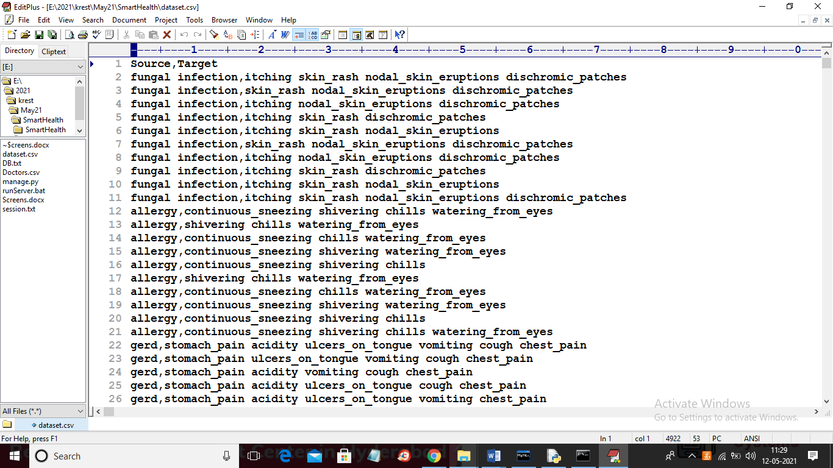

In above screen first row contains column names where source refers to disease name and Target refers to symptoms both source and target is separated by comma and each disease may have multiple symptoms so each symptom is separated by space. For example below is the first line from dataset

**fungal infection** = disease name

**itching skin_rash nodal_skin_eruptions dischromic_patches** = symptoms separated by space and while prediction patient may give one or more symptoms separated by space as input to predict disease

To run project first create database in MYSQL by copying content from ‘DB.txt’ file and paste in MYSQL

Now install python 3.7 and the install below packages

Pip install Django==2.1.7

Pip install sklearn

Pip install numpy==1.19.2

Pip install pandas==0.25.3

Pip install PyMySQL==0.9.3

SCREEN SHOTS

Now double click on ‘runServer.bat’ file to start DJANGO server and then open browser and enter URL as <http://127.0.0.1:8000/index.html> and press enter key to get below home page

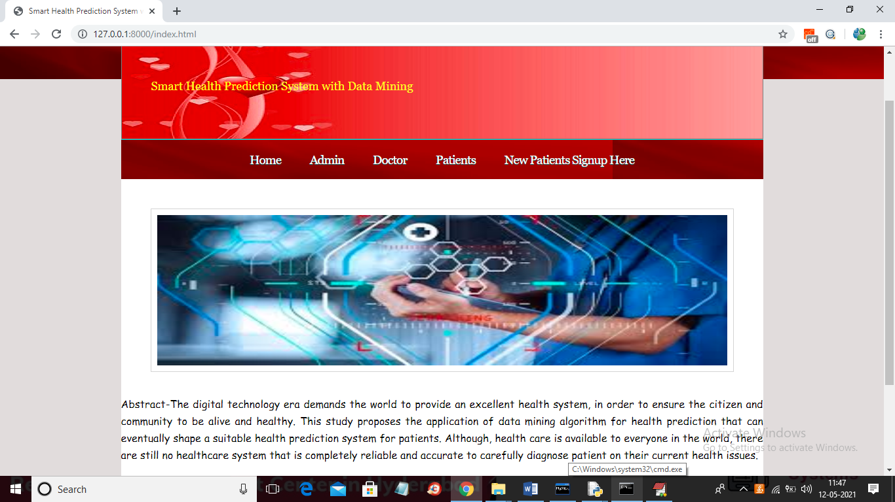

In above screen click on ‘Admin’ link to get below login screen

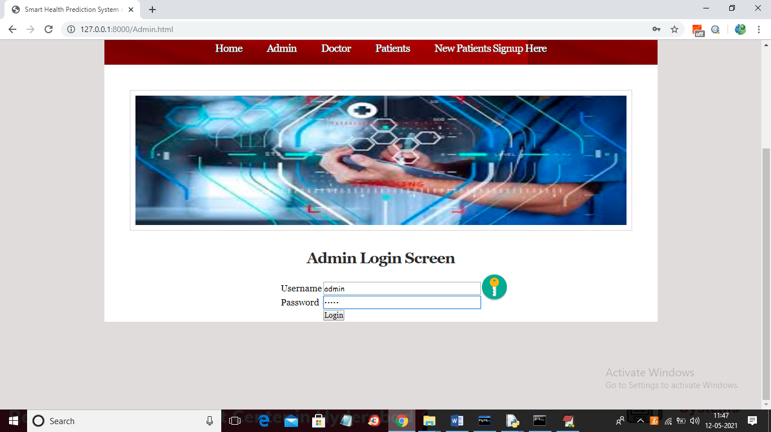

In above screen after login will get below admin screen

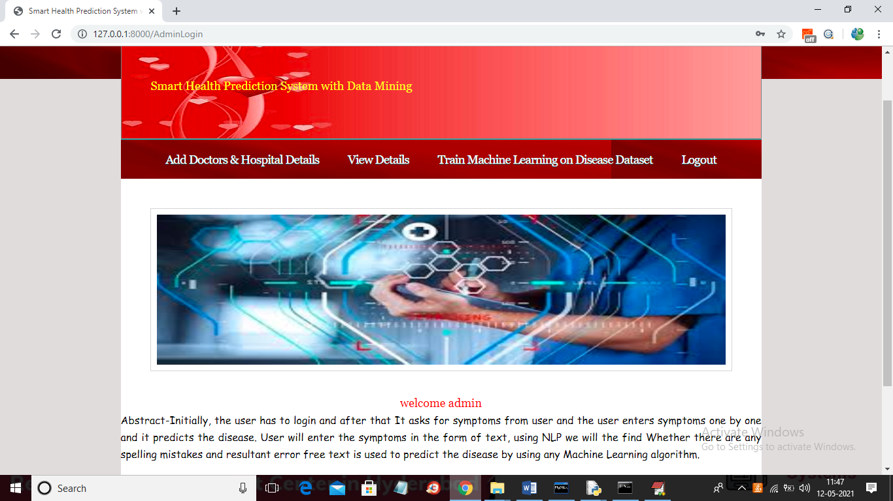

In above screen click on ‘Add Doctors & Hospital Details’ link to add new doctor and if you want you can take doctors details from ‘Doctor.csv’ file available inside code and this file has doctor username, password, latitude, longitude and address details. See below doctors.csv file

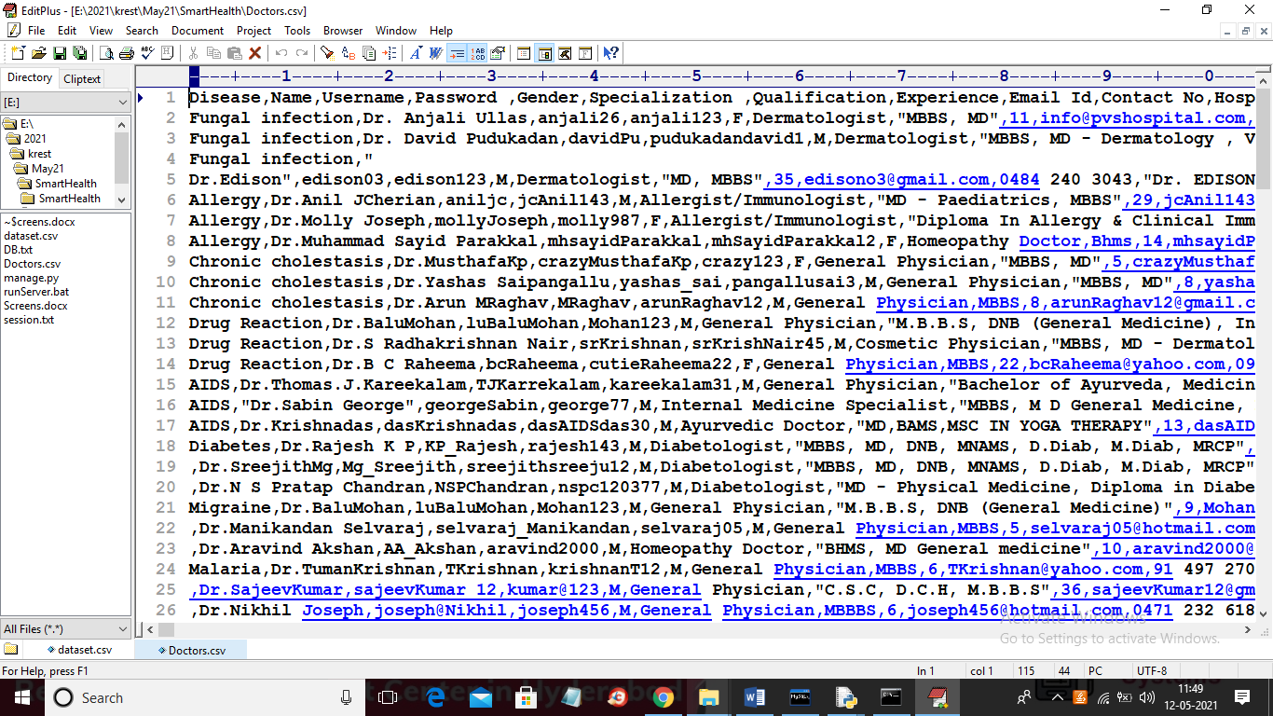

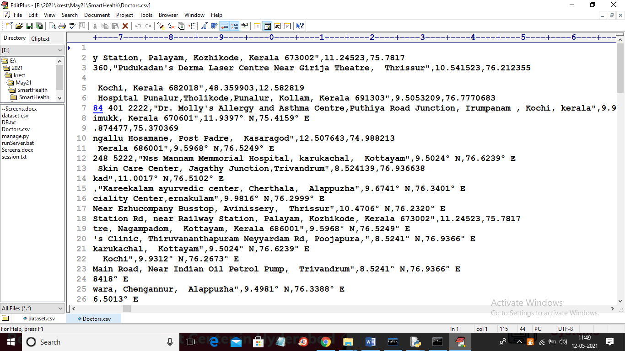

In above screen in last column you can see doctor latitude and longitude and you can use this files to add doctor details by copying content from it

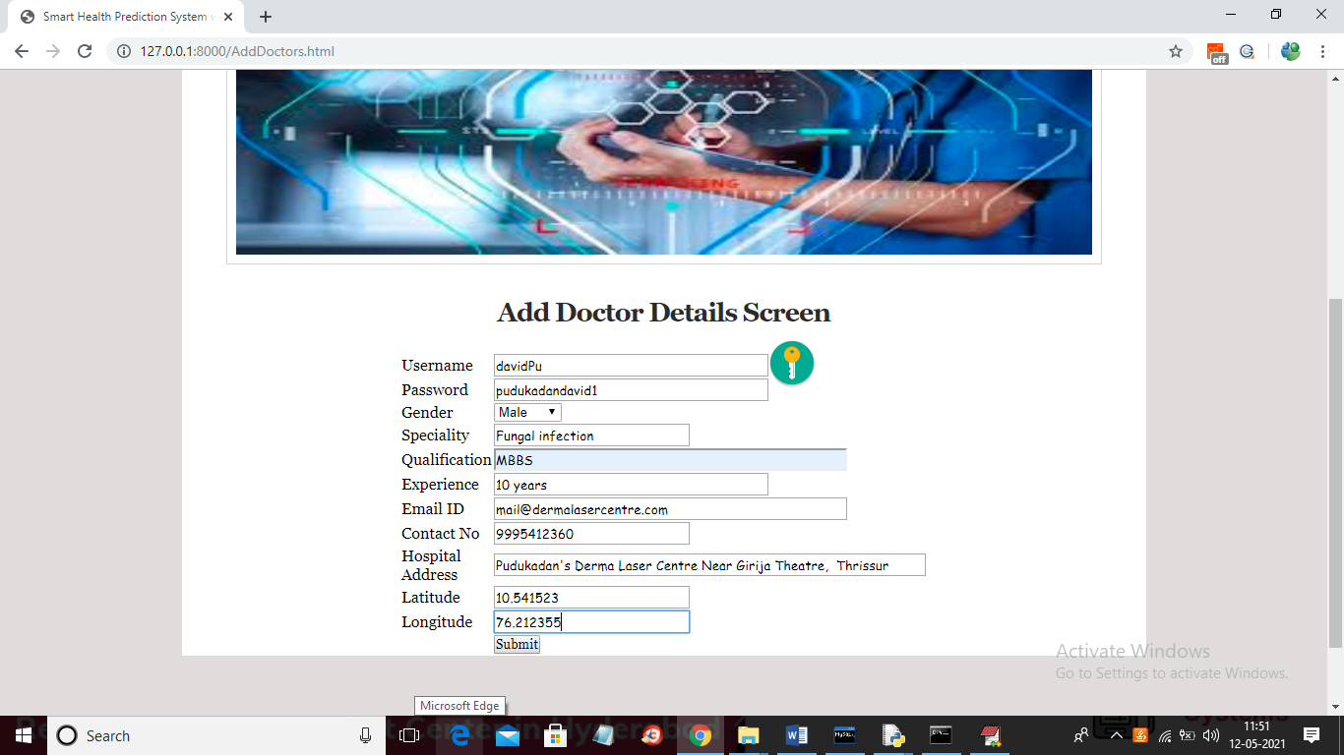

In above screen I added doctor details from same doctors.csv file and if this file contains special symbols such “’s” then remove it otherwise mysql will not accept it and click on submit button to save doctor

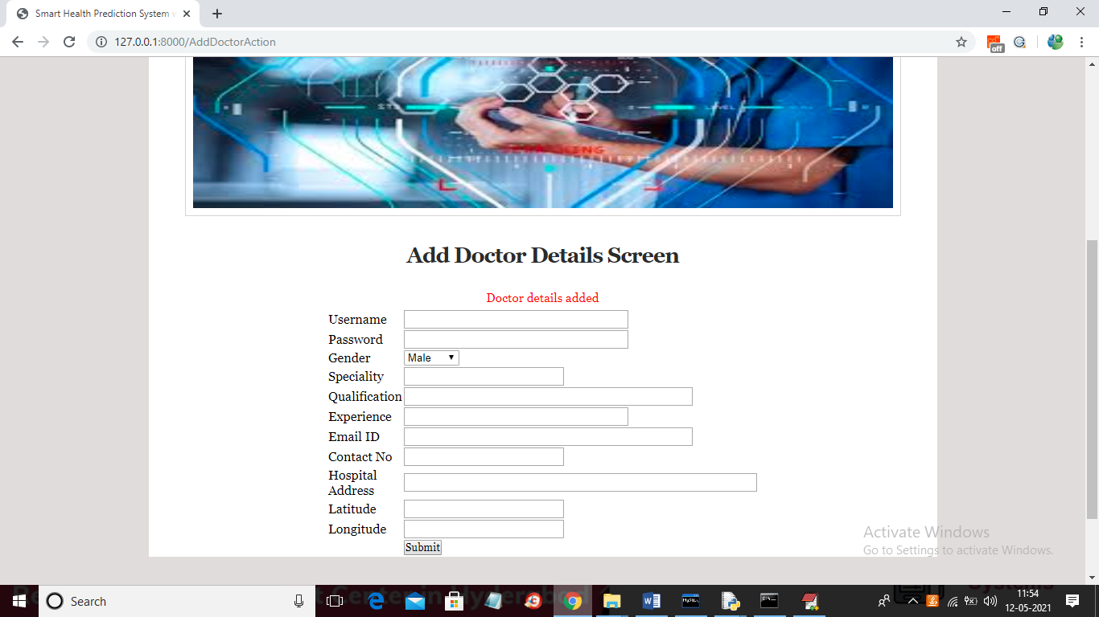

Now admin can click on ‘View Details’ link to get all doctor details in below screen

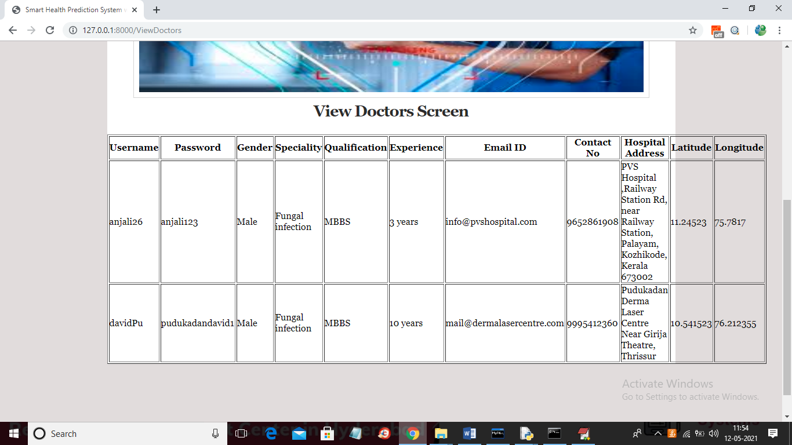

In above screen admin can view all doctor details and now click on ‘Train Machine Learning on Disease Dataset’ link to train Random Forest and other machine learning algorithm

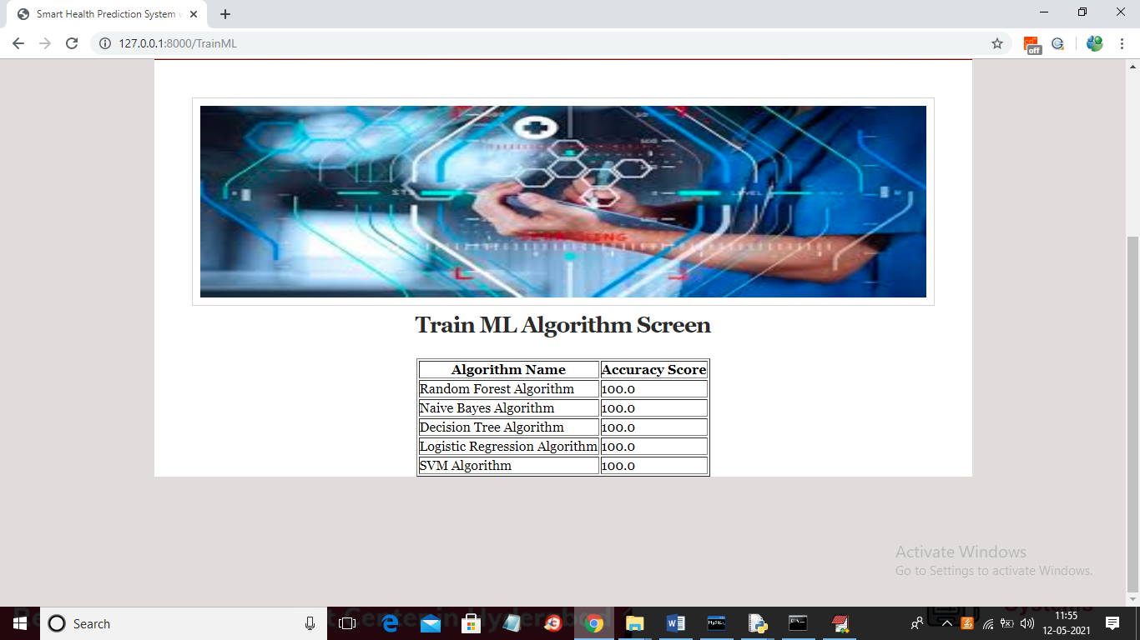

In above screen we trained various data mining algorithms and due to huge dataset size all algorithms got 100% prediction accuracy which means we will get accurate disease prediction and now logout and go for patient signup

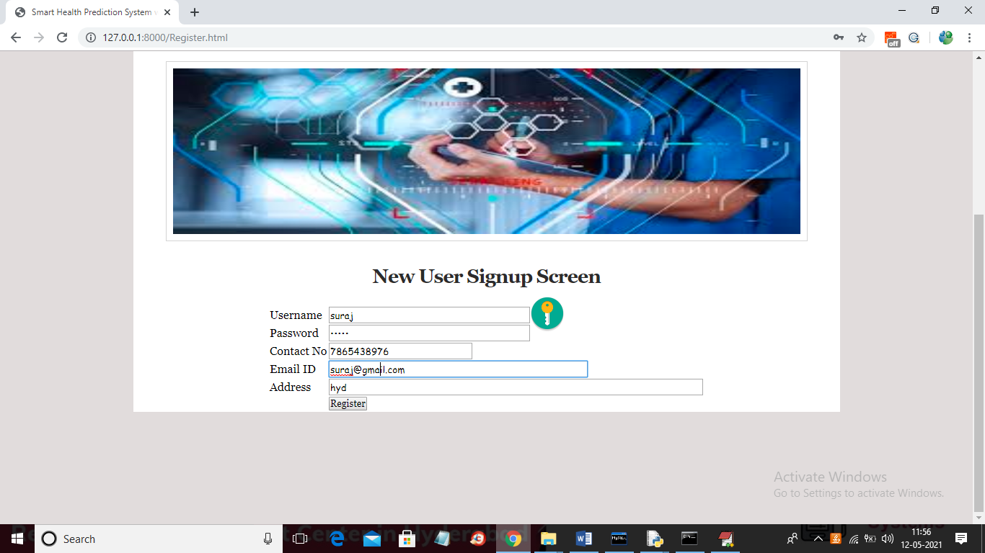

In above screen patients can signup and then click on ‘Register’ button to complete signup process and to get below screen

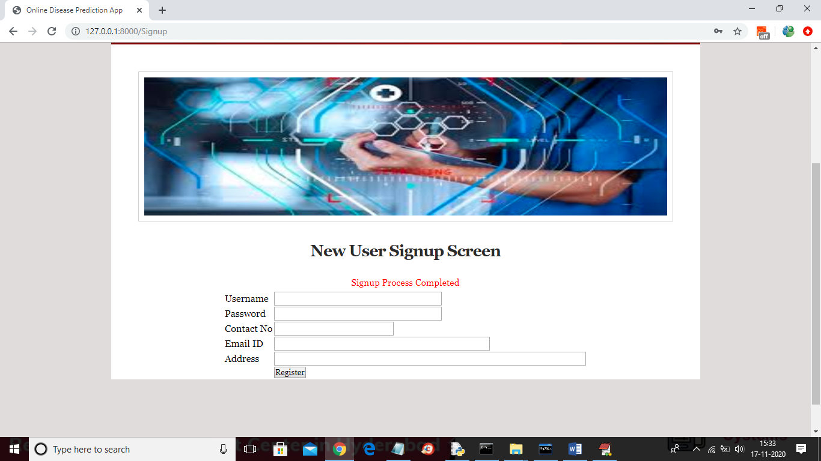

In above screen signup process completed and now patient can login in below screen

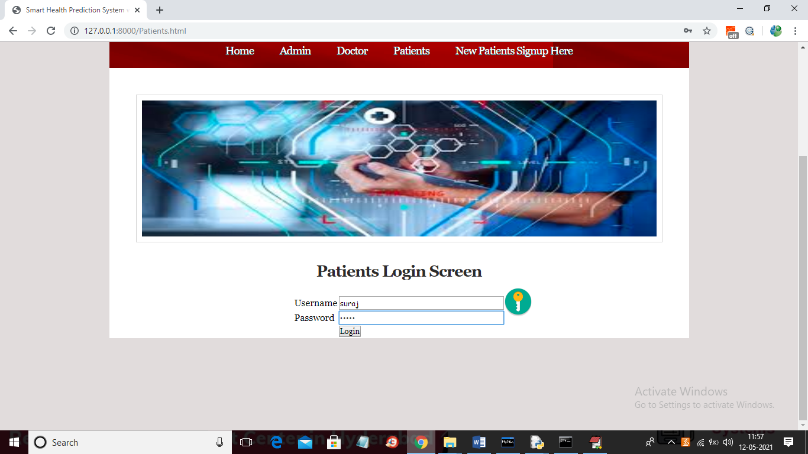

In above screen patient is logged in and after login will get below patient screen

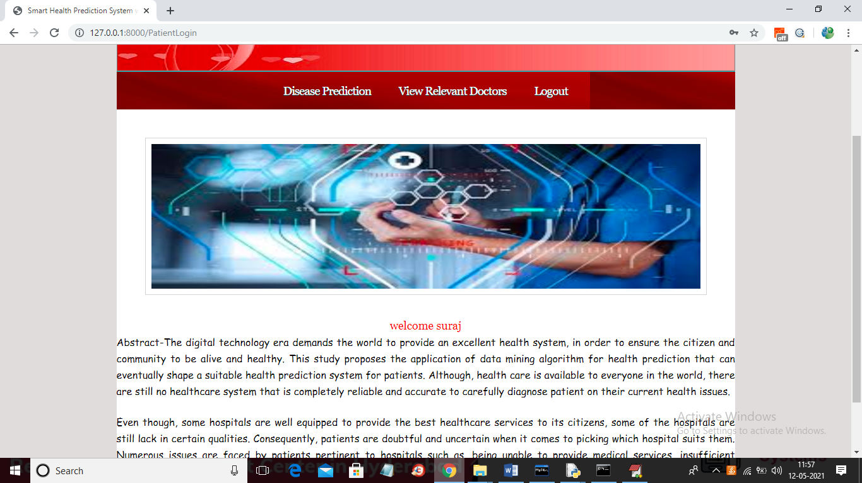

In above screen patient can click on ‘Disease Prediction’ link to get below screen and then patient can enter symptoms separated by space and if you want you can copy symptoms from dataset file also

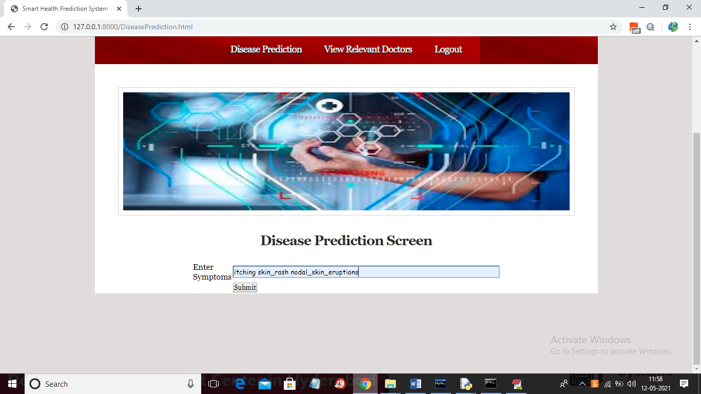

In above screen I entered symptom as ‘itching skin_rash nodal_skin_eruptions’ and then click on ‘Submit’ button to get below result

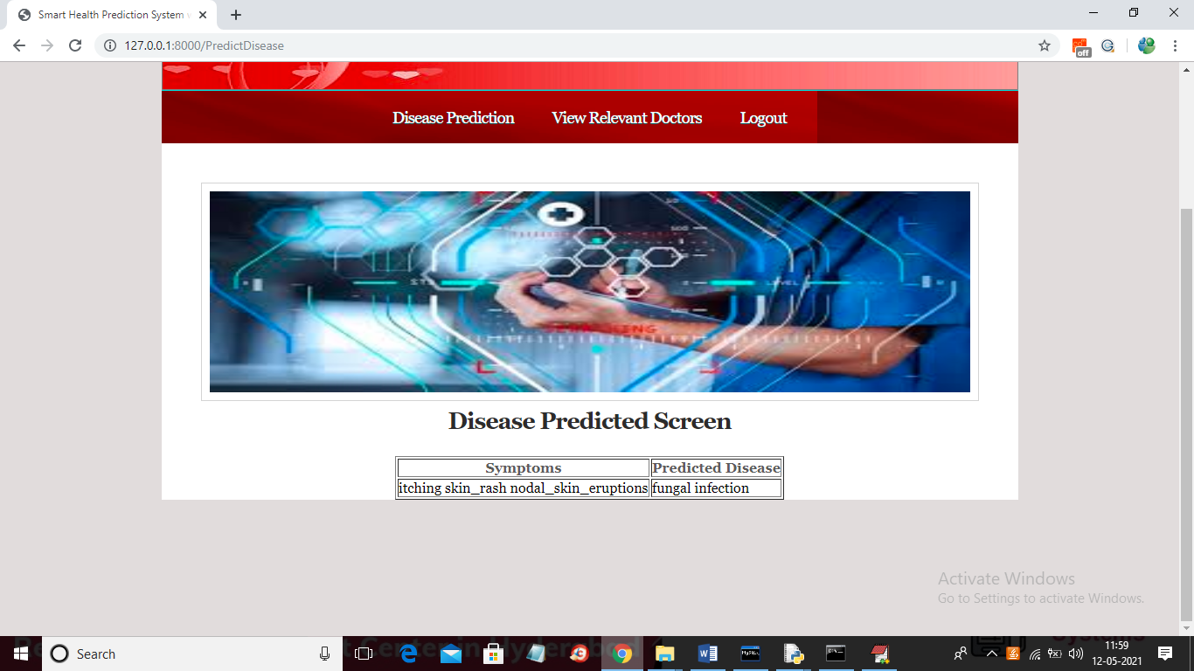

In above screen for given symptoms disease is predicted as ‘fungal infection’ and now patient can click on ‘View Relevant Doctors’ link to search and view doctors related to fungal infection

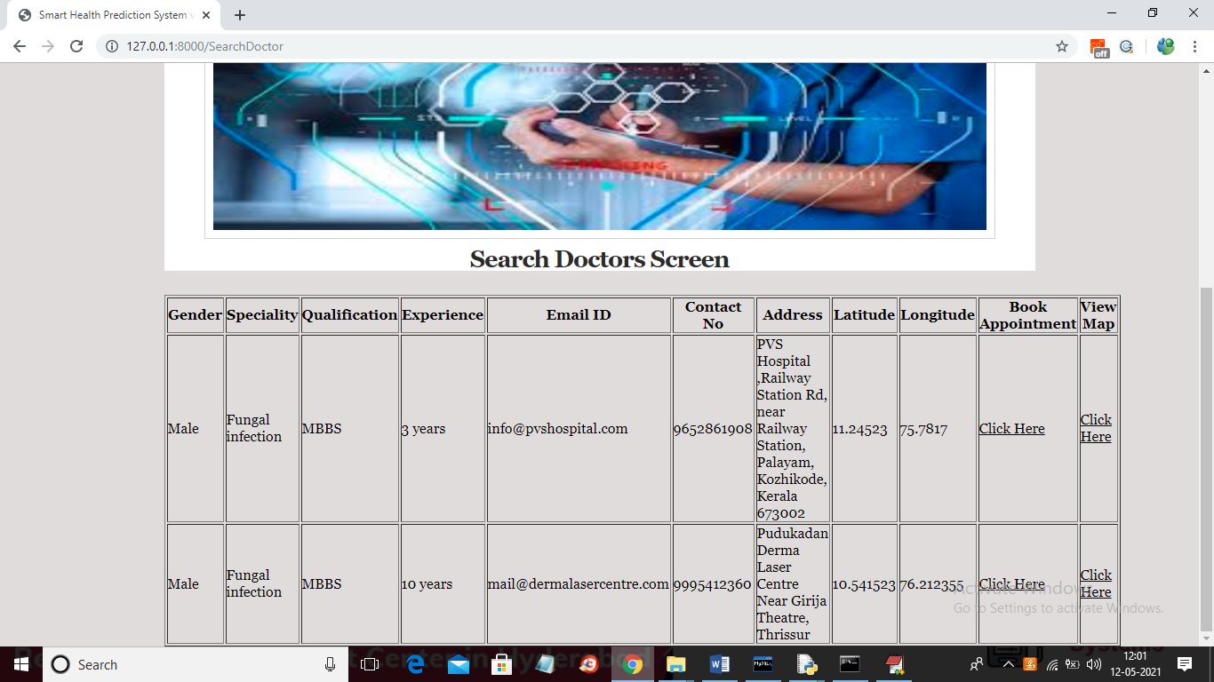

In above screen patient can see 2 doctors for fungal infection and then patient can click on ‘Click Here’ link under ‘View Map’ column to view doctor address in map like below screen

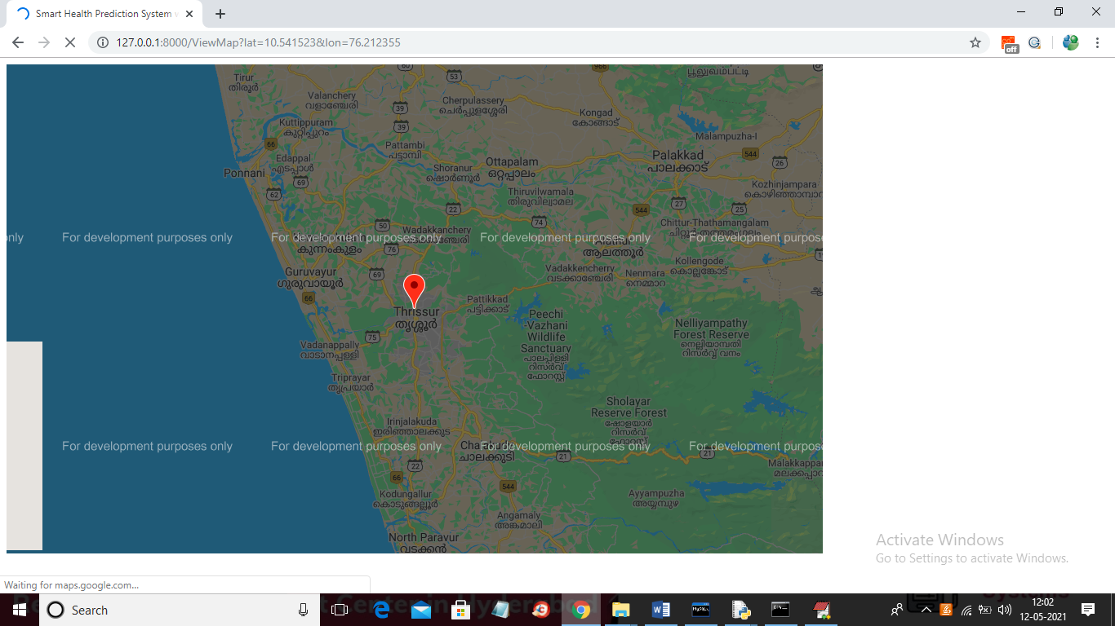

In above screen patient can view doctor address in map and now go back and click on ‘Click Here’ link under ‘Book Appointment’ column to book appointment to get below screen

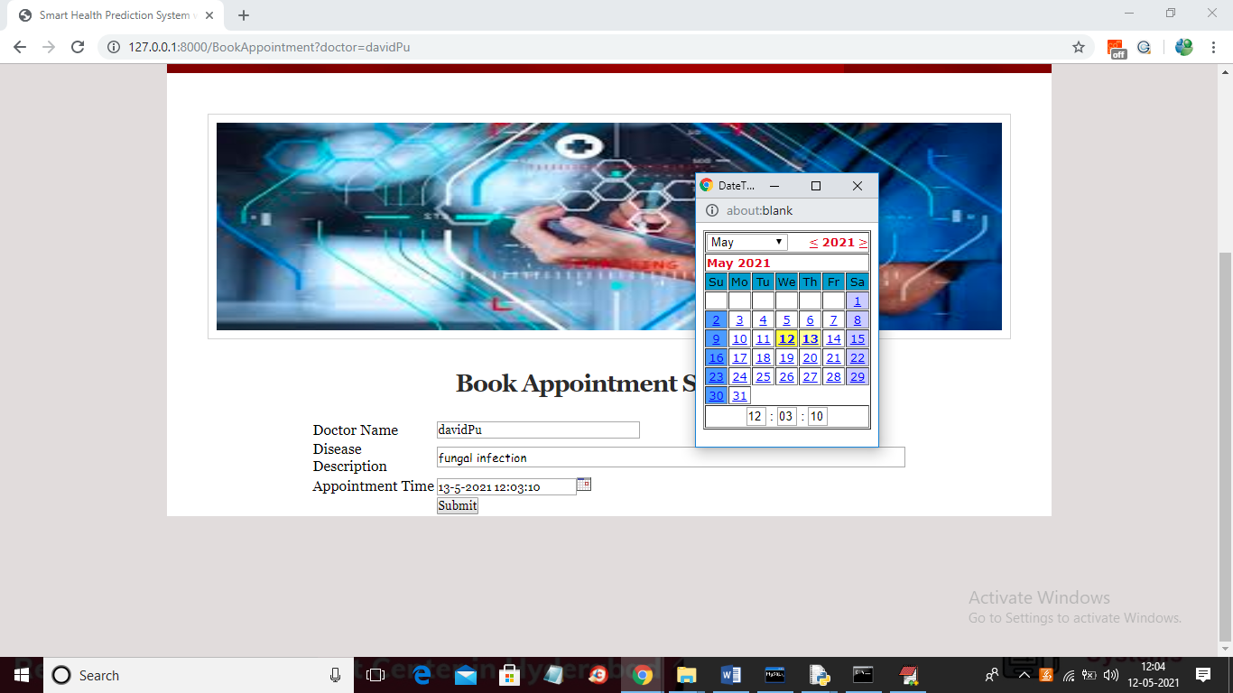

In above screen selected doctor name will be displayed and patient may enter disease name and then select appointment date and time to book appointment and then click submit button to get below screen

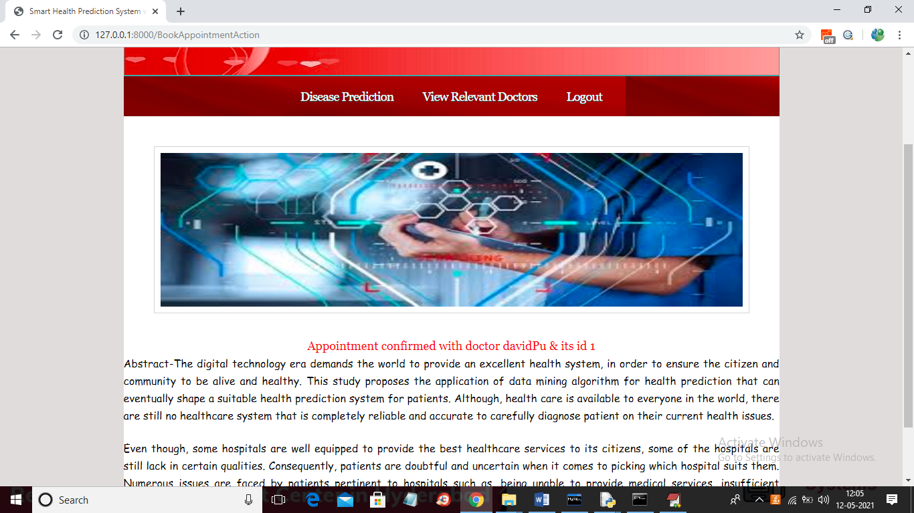

In above screen appointment is confirmed with ‘davidPu’ doctor and now logout and login as doctor to view appointment

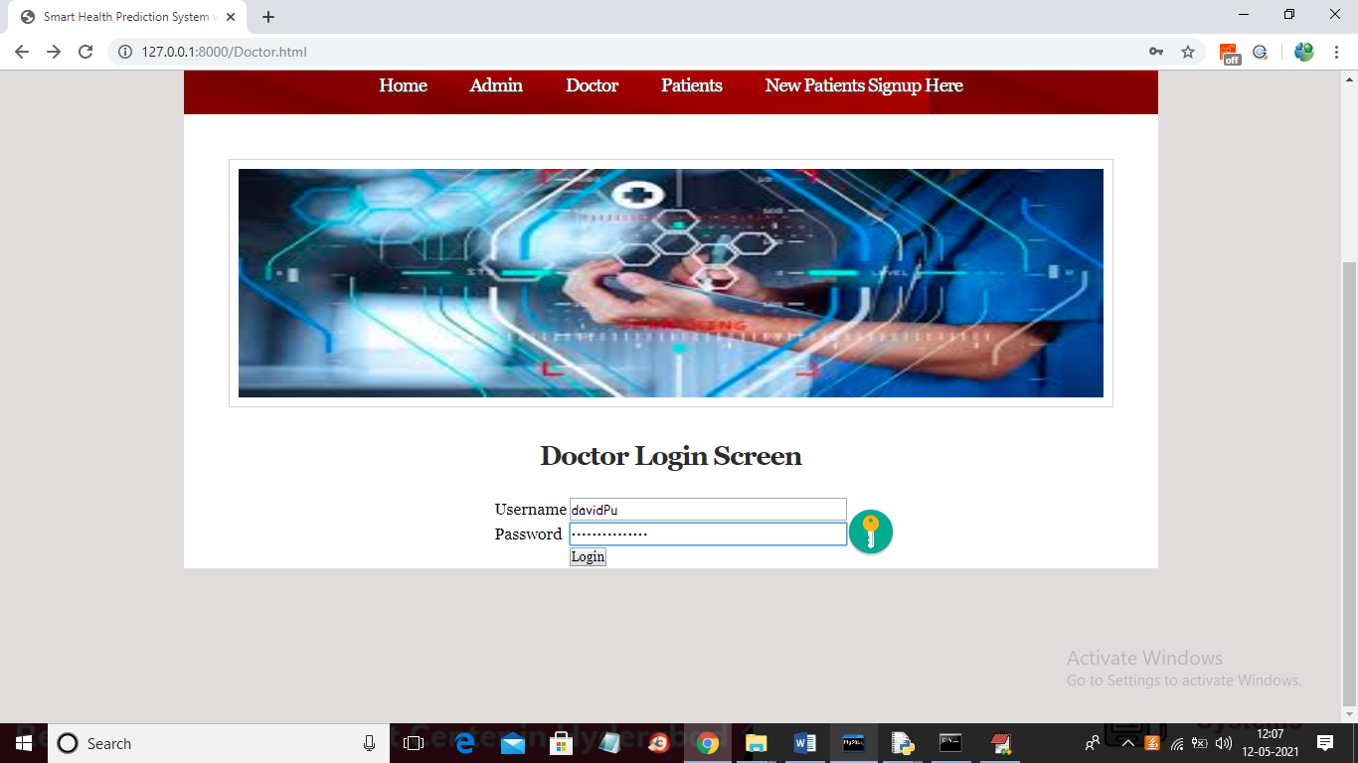

In above screen doctor is login and this login details are given by admin while adding doctors and after login doctor may get below screen

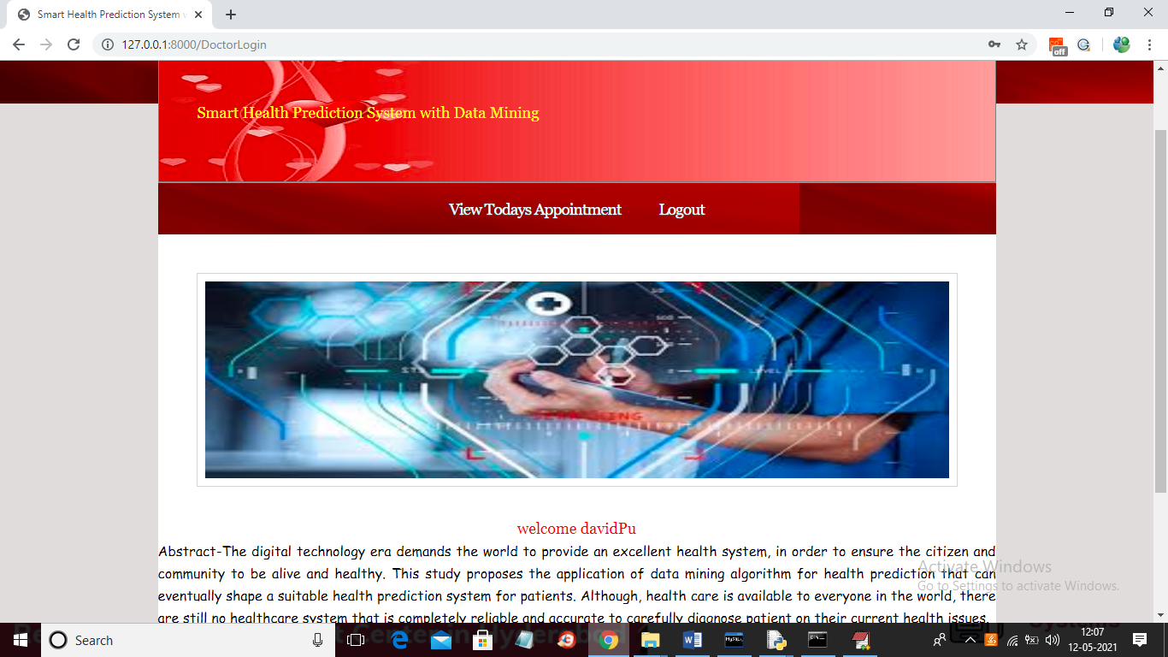

In above screen doctor can click on ‘View Todays Appointment’ button to view appointment and to get below appointment details from patients

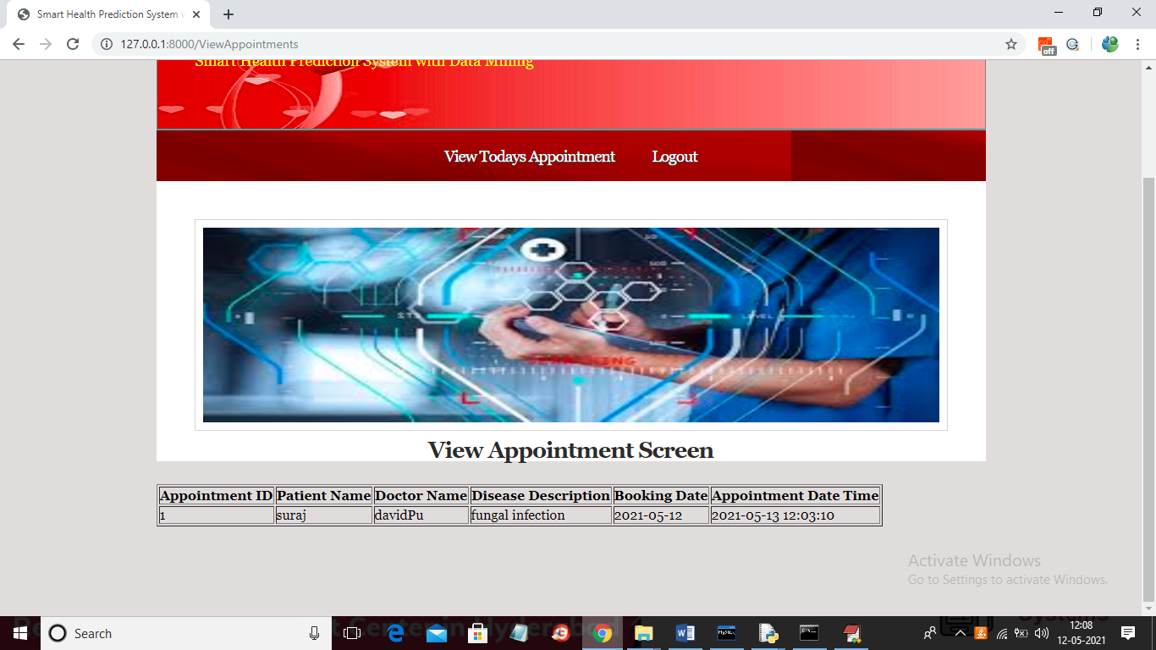

In above screen doctor can view patient appointment details.

Similarly you can add N number of patients and doctors and can perform disease prediction by giving symptoms from dataset